True/false:

T | - In classification using decision trees, if the tree is fully completed in depth, it is more likely that it fits noise in the data hence become overfitting.
T | - K-mean assigns each instance, or case, to a unique cluster based on the distance that it has to the cluster center.
T | - The value of TFIDF is specific to a single document, whereas IDF value depends on the entire corpus.
T | - In text mining, if an association between two concepts has 7% support, it means that 7% of the documents had both concepts represented in the same document.
T | - The Apriori algorithm uses a generate-and-count strategy for deriving frequent itemsets.
F | - The equi-depth approach divides the range of attribute into a user-specified number of intervals each having the same width.
F | - An equi-width approach tries to put the same number of objects into each interval.
T | - In sentiment analysis, it is hard to classify some subjects such as news as good or bad, but easier to classify others, e.g., movie reviews, in the same way.
T | - The confusion matrix is a technique used to evaluate the results of classification, in terms of correctness and errors.
F | - Confidence does not change by itemset order change, whilst support does change when the itemset order change.
F | - K-mean defines the prototype in terms of the most representative point for a group of points.
T | - Root node has no incoming edges and zero or more outgoing edges.
F | - Internal node has one or more incoming and two or more outgoing edges.
F | - Leaf node has exactly one incoming and one outgoing edge. Each leaf node is assigned a class label.
F | - Tokenizing is the process of reducing multiple words to their base or root and then transforming the term-by-document matrix to a manageable size.

MCQ:

Use these tables to answer next two questions:
Single Item Sets | Number of Items
Magazine Promo = Yes | 7
Watch Promo = No | 6
Life Ins Promo = Yes | 5
Life Ins Promo = No | 5
Card Insurance = No | 8
Sex = Male | 6

Two Item Sets | Number of Items
Magazine Promo = Yes & Watch Promo = No | 4
Magazine Promo = Yes & Life Ins Promo = Yes | 5
Magazine Promo = Yes & Card Insurance = No | 5
Watch Promo = No & Card Insurance = No | 5

- One two-item set rule that can be generated from the tables above is: If Magazine Promo = Yes Then Life Ins promo = Yes. The confidence for this rule is:
- 5 / 7
- 5 / 12
- 7 / 12
- 1

- Based on the two-item set table, which of the following is not a possible two-item set rule?
- IF Life Ins Promo = Yes THEN Magazine Promo = Yes
- IF Watch Promo = No THEN Magazine Promo = Yes
- IF Card Insurance = No THEN Magazine Promo = Yes
- IF Life Ins Promo = No THEN Card Insurance = No

- In estimating the accuracy of data mining classification models, true positive rate is:
- The ratio of correctly classified positives divided by the total positive count
- The ratio of correctly classified negatives divided by the total negatives count
- The ratio of correctly classified positives divided by the sum of correctly classified positives and incorrectly classified posivitives
- The ratio of correctly classified negatives divided by the sum of correctly classified positives and incorrectly classified negatives

- Which of the following classifiers fall in the category of lazy learners?
- Decision trees
- Bayesian classifier
- K-NN classifier
- Rule-based classifier

- In KNN classification, choosing high values of K results in:
- predicting the most frequent class label
- increasing the risk of overfitting due to noise in the training data
- avoiding over-smoothing
- increasing the risk of underfitting

Problems/Mini Case Questions:

In the below diagram, there exist a point with a question mark “?”, which needs to be classified.

    - Explain which data mining technique should be used in this classification? k-Nearest neighbor classification [K-NN]
    - Explain how it could be used to label the “?”. The point to be classified, labeled with a question mark, would be classified + if we assume k=3, because the majority of its nearest (three) neighbors are +

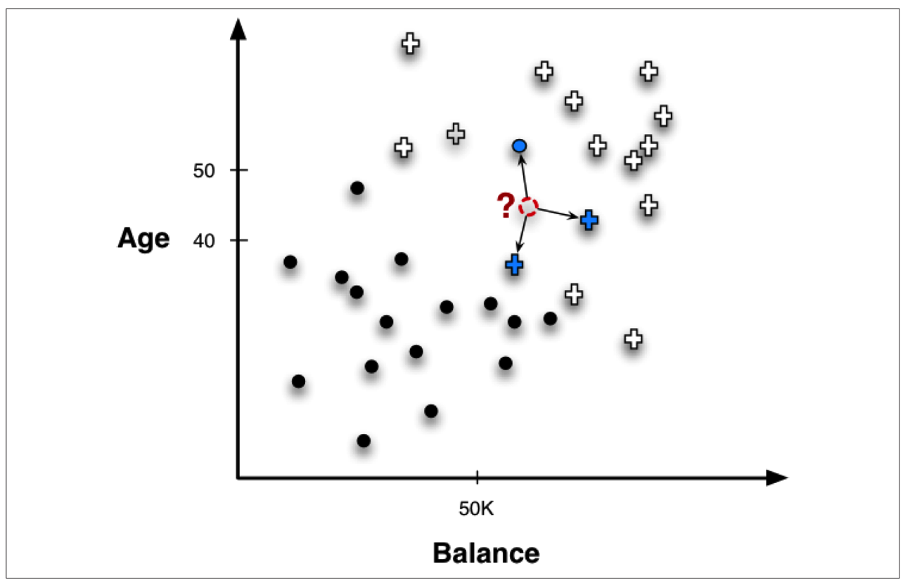

Consider the below credit card marketing problem. The goal is to predict whether a new customer will respond to a credit card offer based on how other similar customers have responded. The data are shown in the below table:

Customer | Age | Income (K) | Cards | Response (class label) | Distance from David
David | 37 | 50 | 2 | ? | 0
John | 35 | 35 | 3 | Y | 15.6
Rachel | 22 | 50 | 3 | N | 15
Ruth | 63 | 200 | 1 | N | 152.23
Jefferson | 59 | 170 | 1 | N | 122
Norah | 25 | 40 | 4 | Y | 15.74

Questions:
- Calculate the distance column.
See table
- Given that K=3, what will be David’s response?
Three are closely similar to David: Rachel, John, and Norah. Their responses are N, Y, Y respectively. If you take majority vote, then David will respond positively (Y).

- How does the answer change, if K=4?
Yes, as we will have to include Jefferson and it is a N; i.e., then it is a tie 50%-50% then relative voting is required. {Relative majority is not required; no normalization is required}

- A Classification: Below is a two-class classification problem of predicting whether a photograph contains a man or a woman.

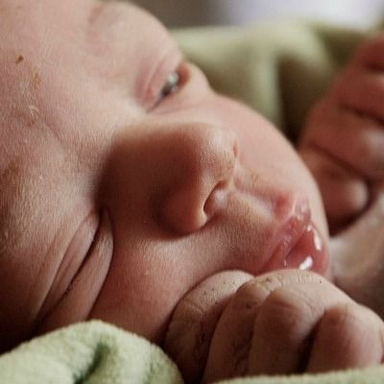

We have a test dataset of 10 records with expected outcomes and a set of predictions from our classification algorithm. See below table.

 | Expected | Predicted
1 | Man | Woman
2 | Man | Man
3 | Woman | Woman
4 | Man | Man
5 | Woman | Man
6 | Woman | Woman
7 | Woman | Woman
8 | Man | Man
9 | Man | Woman
10 | Woman | Woman

- What is the classification accuracy for this set of predictions?
The algorithm made 7 of the 10 predictions correct with an accuracy of 70%.
- What is the error rate?
30%.
- Calculate the number of correct predictions for each class.
Men classified as men = 3
Woman classified as women = 4
- Calculate the number of incorrect predictions for each class, organized by the predicted value.

Men classified as women = 2
Woman classified as men = 1
- Arrange these values into the 2-class confusion matrix.

 | Men | Women
Men | 3 | 1
Women | 2 | 4

- What is the total number of men in the dataset?
It is the sum of the values on the men column (3 + 2)

- What is the total number of women in the dataset?
It is the sum of values in the women column (1 +4)

